A Statement of Attainment
is issued by a Registered Training Organisation when an individual has completed one or more accredited units

This is a statement that

Brendon Beirne

has attained

RSALRA001 Lead Road Safety Audits

These competencies form part of

10799 NAT Course in Road Safety Audits

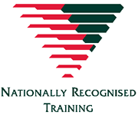  Date: 6 July 2020  Certificate No: 103019  Professional Development Hours: 16 | 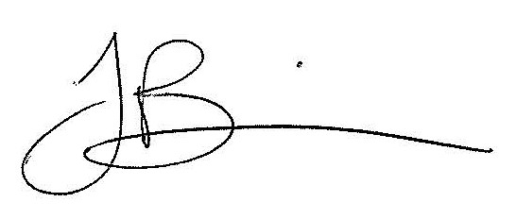  Francine Binns  Chief Executive Officer  NSW Division  RTO 90174  Level 12, 447 Kent Street, Sydney NSW 2000

